MGMS – Search Project

Detailed Design Document

Ver. 1.4

Version History
Date | Description
21-Oct-2010 | First Draft
22-Dec-2010 | New sections – Grant search & Advanced search

Table of Contents

Version History 2
1 Introduction 4
1.1 Purpose 4
2 Sub menu – Search Projects 4
2.1 Simple Search 4
2.2 Advanced Search 5
2.3 Grant Search 7
3 Associated Tables 7
4 Data Dictionary 8

Introduction

Purpose

This document provides the detailed design specifications for the Multisite Grant Management System project.

This is not a project plan nor does it detail the source code. It is a guide for system architecture and development, not for phasing, timelines or deliverables.

Finally, this is a ‘living document’ and the specification will change, continuously, as the project proceeds. More details will be added and the existing information edited as the requirements, architecture and design evolve in the course of the project.

Sub menu – Search Projects

Simple Search

Clicking on Search Projects on the left navigation bar opens the page as shown below.

Screen & Control Description

Figure 1: Project – Simple search
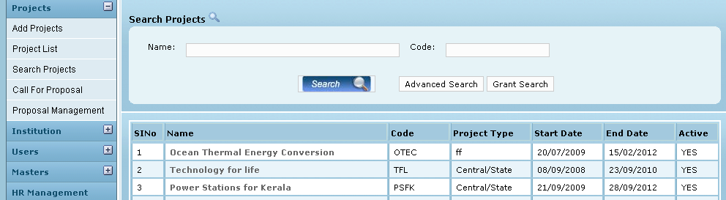

Field /Label | Input-Control | Data Type | Remarks/db table>field
Search Projects
Name: | Textbox | varchar(255) | projects>name
Code: | Textbox | varchar(255) | projects>code
Project Type: | Listbox
Principal Investigator: | Listbox | varchar(255) | investigator>name
Search | Button |  | On clicking, the table below is populated with criteria satisfying projects.
SlNo | Auto increment populated
Name | Auto populated | varchar(255) | projects>name
Code | Auto populated | varchar(255) | projects>code
Project Type | Auto populated | varchar(255) | project_type>type
Start Date | Auto populated | datetime | projects>project_start_date
End Date | Auto populated | datetime | projects>project_end_date
Active | Auto populated | char(1) | projects>active-yes_no

Clicking on Advanced Search will open the page as shown below:

Advanced Search

Figure 2: Project – Advanced search
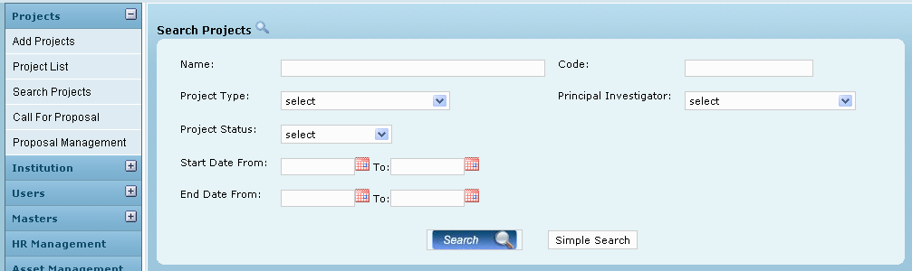

As can be seen, more search criteria can be given to narrow down the search. Clicking on Simple Search reverts back to the main search page

Field /Label | Input-Control | Data Type | Details
Search Projects
Name: | Textbox | varchar(255) | projects>name
Code: | Textbox | varchar(255) | projects>code
Project Type: | Listbox | varchar(255) | project_type>type
Principal Investigator: | Listbox | varchar(255) | investigator>name
Project Status | Listbox | varchar(255) | project_tracking>project_status
Start Date From/To
End Date From/To
Search | Button |  | On clicking, the table below is populated with criteria satisfying projects.
Simple Search |  |  | On clicking, the Simple search screen opens up as shown in Fig 1
SlNo | Auto increment populated
Name | Auto populated | varchar(255) | projects>name
Code | Auto populated | varchar(255) | projects>code
Project Type | Auto populated | varchar(255) | project_type>type
Start Date | Auto populated | datetime | projects>project_start_date
End Date | Auto populated | datetime | projects>project_end_date
Active | Auto populated | char(1) | projects>active-yes_no

Clicking on “Grant Search”, as the name implies, opens the page as shown below:

Grant Search

Figure 3: Grant Search
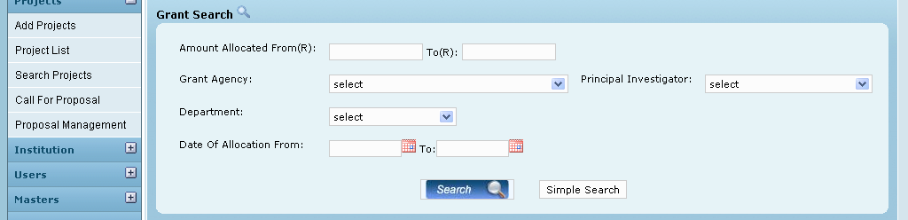

Field /Label | Input-Control | Data Type | Details
Search Projects
Amount allocated from/to: | 2 Textboxes | double | grant_allocation>amount_allocated
Grant Agency: | Textbox | varchar(255) | party>code
Department: | Listbox | varchar(255) | party_departmnet>name
Principal Investigator: | Listbox | varchar(255) | investigator>name
Search | Button
SlNo | Auto increment populated
Name | Auto populated | varchar(255) | projects>name
Code | Auto populated | varchar(255) | projects>code
Project Type | Auto populated | varchar(255) | project_type>type
Start Date | Auto populated | datetime | projects>project_start_date
End Date | Auto populated | datetime | projects>project_end_date
Active | Auto populated | char(1) | projects>active-yes_no

Clicking on Simple Search reverts back to the main search page

Associated Tables

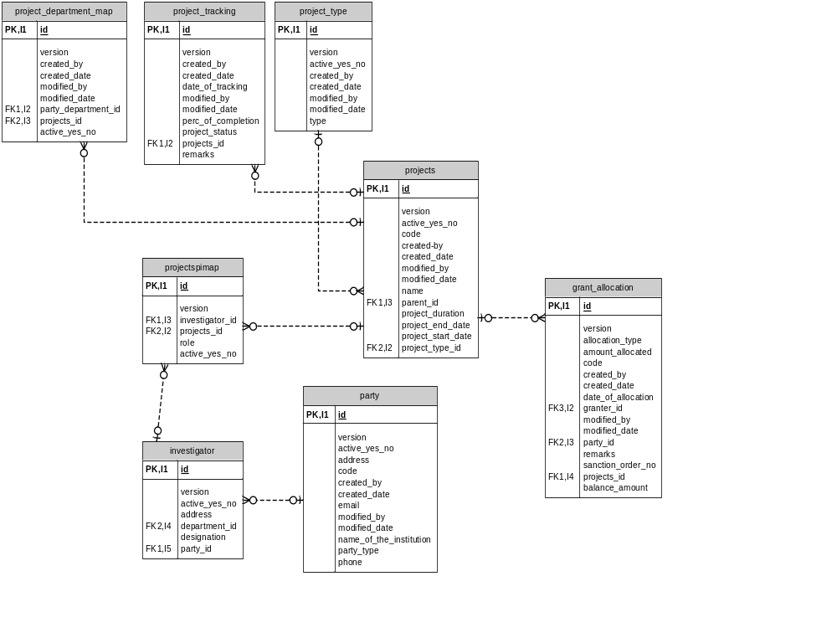

Data Dictionary

investigator

Fields

Field | Type | Collation | Null | Key | Default | Extra | Privileges | Comment
id | bigint(20) | (NULL) | NO | PRI | (NULL) | auto_increment | select,insert,update,references
version | bigint(20) | (NULL) | NO |  |  |  | select,insert,update,references
active_yes_no | char(1) | latin1_swedish_ci | NO |  |  |  | select,insert,update,references
address | varchar(255) | latin1_swedish_ci | NO |  |  |  | select,insert,update,references
department_id | bigint(20) | (NULL) | NO | MUL |  |  | select,insert,update,references
designation | varchar(255) | latin1_swedish_ci | NO |  |  |  | select,insert,update,references
email | varchar(255) | latin1_swedish_ci | NO | UNI |  |  | select,insert,update,references
name | varchar(255) | latin1_swedish_ci | NO | UNI |  |  | select,insert,update,references
party_id | bigint(20) | (NULL) | NO | MUL |  |  | select,insert,update,references

Indexes

Table | Non  unique | Key  name | Seq  in  index | Column  name | Collation | Cardinality | Sub  part | Packed | Null | Index  type | Comment
investigator | 0 | PRIMARY | 1 | id | A | 31 | (NULL) | (NULL) |  | BTREE
investigator | 0 | email | 1 | email | A | 31 | (NULL) | (NULL) |  | BTREE
investigator | 0 | name | 1 | name | A | 31 | (NULL) | (NULL) |  | BTREE
investigator | 1 | FK967BBBA99F389FE0 | 1 | department_id | A | 31 | (NULL) | (NULL) |  | BTREE
investigator | 1 | FK967BBBA94B78CFDA | 1 | party_id | A | 31 | (NULL) | (NULL) |  | BTREE

Foreign Key Relationships

FK Id | Reference Table | Source Column | Target Column | Extra Info
FK967BBBA94B78CFDA | party | `party_id` | `id` | ,
FK967BBBA99F389FE0 | party_department | `department_id` | `id`

projectspimap

Fields

Field | Type | Collation | Null | Key | Default | Extra | Privileges | Comment
id | bigint(20) | (NULL) | NO | PRI | (NULL) | auto_increment | select,insert,update,references
version | bigint(20) | (NULL) | NO |  |  |  | select,insert,update,references
investigator_id | bigint(20) | (NULL) | NO | MUL |  |  | select,insert,update,references
projects_id | bigint(20) | (NULL) | NO | MUL |  |  | select,insert,update,references
role | varchar(255) | latin1_swedish_ci | NO |  |  |  | select,insert,update,references
active_yes_no | char(1) | latin1_swedish_ci | YES |  |  |  | select,insert,update,references

Indexes

Table | Non  unique | Key  name | Seq  in  index | Column  name | Collation | Cardinality | Sub  part | Packed | Null | Index  type
projectspimap | 0 | PRIMARY | 1 | id | A | 169 | (NULL) | (NULL) |  | BTREE
projectspimap | 1 | FKEA00CC89905C4B9A | 1 | projects_id | A | 169 | (NULL) | (NULL) |  | BTREE
projectspimap | 1 | FKEA00CC89893BB93A | 1 | investigator_id | A | 42 | (NULL) | (NULL) |  | BTREE

Foreign Key Relationships

FK Id | Reference Table | Source Column | Target Column | Extra Info
FKEA00CC89893BB93A | investigator | `investigator_id` | `id` | ,
FKEA00CC89905C4B9A | projects | `projects_id` | `id`

projects

Fields

Field | Type | Collation | Null | Key | Default | Extra | Privileges
id | bigint(20) | (NULL) | NO | PRI | (NULL) | auto_increment | select,insert,update,references
version | bigint(20) | (NULL) | NO |  |  |  | select,insert,update,references
active_yes_no | char(1) | latin1_swedish_ci | NO |  |  |  | select,insert,update,references
code | varchar(255) | latin1_swedish_ci | NO |  |  |  | select,insert,update,references
created_by | varchar(255) | latin1_swedish_ci | NO |  |  |  | select,insert,update,references
created_date | datetime | (NULL) | NO |  |  |  | select,insert,update,references
modified_by | varchar(255) | latin1_swedish_ci | NO |  |  |  | select,insert,update,references
modified_date | datetime | (NULL) | NO |  |  |  | select,insert,update,references
name | varchar(255) | latin1_swedish_ci | NO |  |  |  | select,insert,update,references
parent_id | bigint(20) | (NULL) | YES | MUL | (NULL) |  | select,insert,update,references
project_duration | varchar(255) | latin1_swedish_ci | YES |  | (NULL) |  | select,insert,update,references
project_end_date | datetime | (NULL) | YES |  | (NULL) |  | select,insert,update,references
project_start_date | datetime | (NULL) | YES |  | (NULL) |  | select,insert,update,references
project_type_id | int(11) | (NULL) | NO | MUL |  |  | select,insert,update,references

Indexes

Table | Non  unique | Key  name | Seq  in  index | Column  name | Collation | Cardinality | Sub  part | Packed | Null | Index  type | Comment
projects | 0 | PRIMARY | 1 | id | A | 137 | (NULL) | (NULL) |  | BTREE
projects | 1 | FKC479187A69DF6AED | 1 | project_type_id | A | 8 | (NULL) | (NULL) |  | BTREE
projects | 1 | FKC479187A43BA2D6A | 1 | parent_id | A | 137 | (NULL) | (NULL) | YES | BTREE

Foreign Key Relationships

FK Id | Reference Table | Source Column | Target Column | Extra Info
FKC479187A43BA2D6A | projects | `parent_id` | `id` | ,
FKC479187A69DF6AED | project_type | `project_type_id` | `id`

project_type

Fields

Field | Type | Collation | Null | Key | Default | Extra | Privileges | Comment
id | int(11) | (NULL) | NO | PRI | (NULL) | auto_increment | select,insert,update,references
version | bigint(20) | (NULL) | NO |  |  |  | select,insert,update,references
active_yes_no | char(1) | latin1_swedish_ci | NO |  |  |  | select,insert,update,references
created_by | varchar(255) | latin1_swedish_ci | NO |  |  |  | select,insert,update,references
created_date | datetime | (NULL) | NO |  |  |  | select,insert,update,references
modified_by | varchar(255) | latin1_swedish_ci | YES |  | (NULL) |  | select,insert,update,references
modified_date | datetime | (NULL) | YES |  | (NULL) |  | select,insert,update,references
type | varchar(255) | latin1_swedish_ci | NO |  |  |  | select,insert,update,references

Indexes

Table | Non  unique | Key  name | Seq  in  index | Column  name | Collation | Cardinality | Sub  part | Packed | Null | Index  type | Comment
project_type | 0 | PRIMARY | 1 | id | A | 8 | (NULL) | (NULL) |  | BTREE

